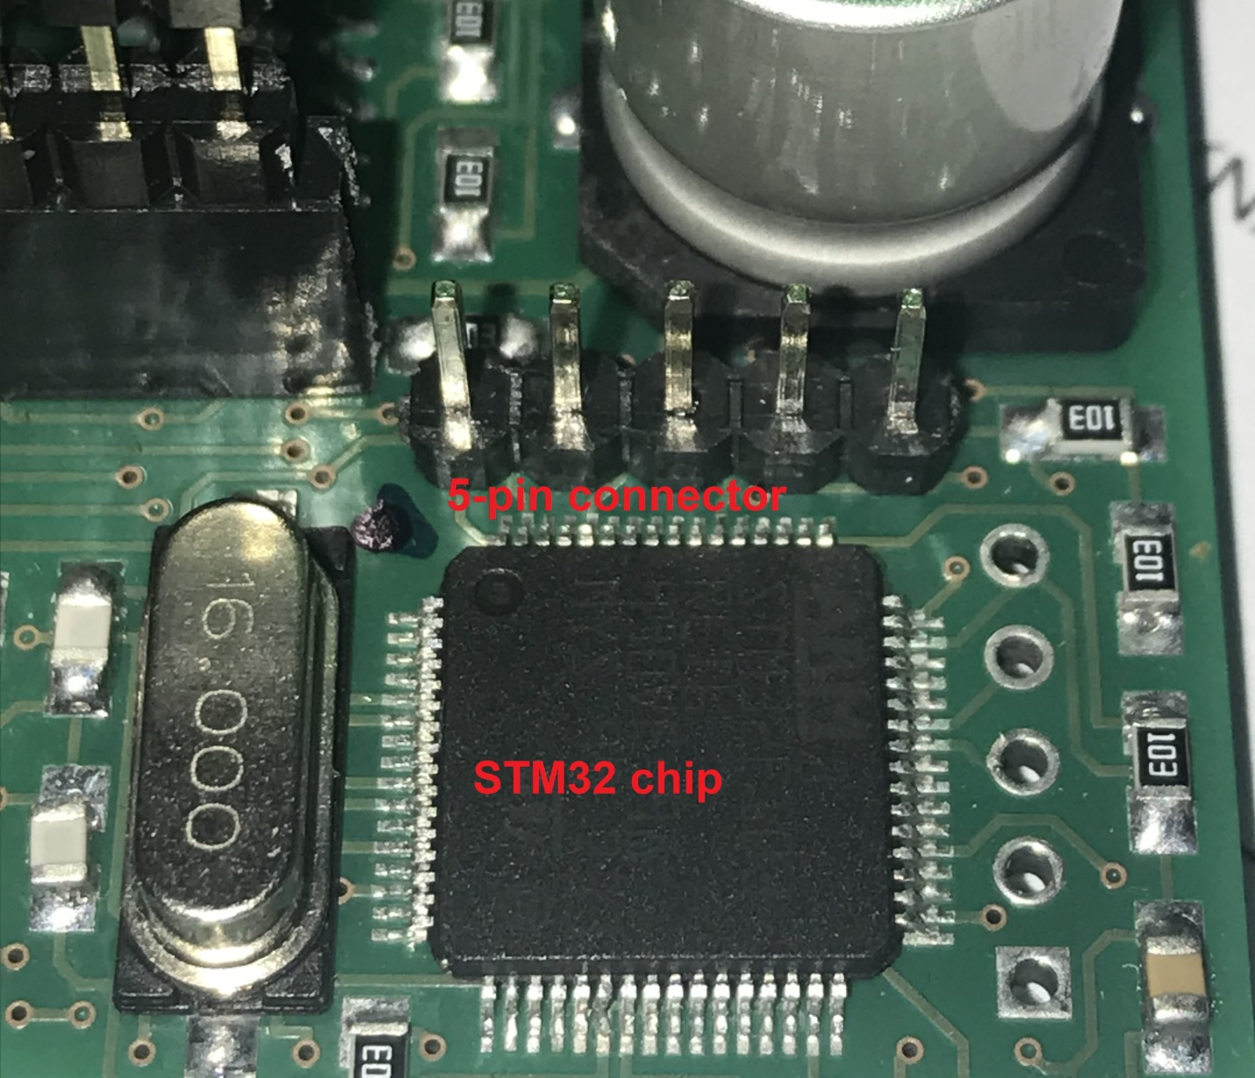
5-pin connector near STM32 chip.
Pin 1 has a rectangular contact area.
Standard ST-LINK/V2 20-pin connector |  | 5-pin connector
1 | Vcc +3,3 Volts | 1
7 | SWDIO | 2
9 | SWCLK | 3
10 | GND | 4
15 | NRST | 5

